Exercise 7: Financial Forecasting
Data Structures and Algorithms – Week 1, Cognizant Assessment

Scenario
The task was to build a financial forecasting tool that predicts a future value from past data, using a recursive algorithm driven by a series of historical growth rates.

1. Recursive Algorithms
Recursion is when a method solves a problem by calling itself with a smaller version of the same problem, until it reaches a case simple enough to answer directly — the base case. It's a natural fit for forecasting: the value in year N is just the value in year N-1, grown by that year's rate. Framed this way, each recursive call only has to handle one year and then hand off a slightly smaller problem (one year closer to the base case) to the next call, instead of writing one large formula up front.

2 & 3. Setup and Implementation
calculateFutureValue() takes the current value and an index into a growthRates array, one entry per year. Each call grows the value by that year's rate and recurses to year + 1. The base case is reached when the index equals the array length, meaning there are no more years left to apply:
public class FinancialForecast {

// Recurses through the growth-rate array one year at a time.
// Base case: no years left -> return the value as is.
// Recursive case: grow the value by this year's rate, move to next year.
public static double calculateFutureValue(double presentValue,
double[] growthRates, int year) {
if (year == growthRates.length) {
return presentValue;
}
double grownValue = presentValue * (1 + growthRates[year]);
return calculateFutureValue(grownValue, growthRates, year + 1);
}
}
A memoized version was also implemented. Since a real forecasting tool is often asked to recompute the same starting value and rate combination more than once (for example, re-running the same “what if” scenario), results are cached by key so repeat calls skip the recomputation entirely:
private static final Map<String, Double> cache = new HashMap<>();

public static double calculateFutureValueMemoized(double presentValue,
double[] growthRates, int year) {
String key = presentValue + "-" + year;
if (cache.containsKey(key)) {
return cache.get(key);
}
double result;
if (year == growthRates.length) {
result = presentValue;
} else {
double grownValue = presentValue * (1 + growthRates[year]);
result = calculateFutureValueMemoized(grownValue, growthRates, year + 1);
}
cache.put(key, result);
return result;
}
Both versions were exercised from a ForecastDemo class using a starting value of 10,000 and five years of historical growth rates (5%, 7%, 4%, 6%, 3%):
double startingValue = 10000.0;
double[] pastGrowthRates = {0.05, 0.07, 0.04, 0.06, 0.03};

double futureValue = FinancialForecast.calculateFutureValue(
startingValue, pastGrowthRates, 0);

double firstCall = FinancialForecast.calculateFutureValueMemoized(
startingValue, pastGrowthRates, 0);
double secondCall = FinancialForecast.calculateFutureValueMemoized(
startingValue, pastGrowthRates, 0); // served from cache

4. Output
Running ForecastDemo in IntelliJ IDEA produced the following console output:
---- Recursive Forecast ----
Starting value: 10000.00
Projected value after 5 years: 12757.03

---- Memoized Forecast (repeated call) ----
First call result: 12757.03 (took 8314300 ns)
Second call result: 12757.03 (took 15400 ns, served from cache)

Process finished with exit code 0
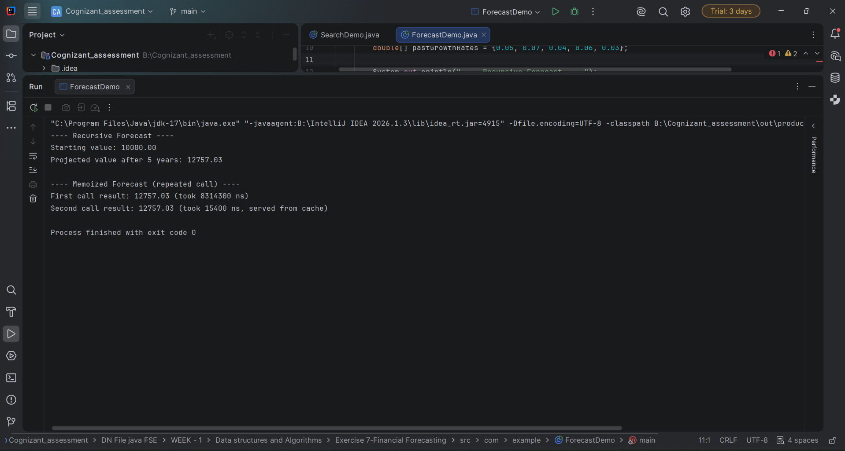
Screenshot: IntelliJ IDEA run console showing the output of ForecastDemo.java.

5. Analysis
The plain recursive algorithm runs in O(n) time, where n is the number of years/growth rates — each call does one multiplication and one recursive call, with no repeated work. Space complexity is also O(n), because of the call stack: every call stays on the stack until the base case is reached and the chain of returns unwinds.
The console output confirms this: the recursive method correctly compounds 10,000 through five years of varying growth rates to land on 12,757.03.
Optimization: because this particular recursion doesn't revisit the same year twice within a single call, memoization mainly helps across repeated calls with identical inputs rather than within one call — which is exactly what the timing shows. The first memoized call took 8,314,300 ns (dominated by JVM class-loading/warm-up on first use, not the math itself), while the second call with the same inputs was served straight from the cache in 15,400 ns. For very large numbers of years, the more impactful optimization would be converting the recursion into a simple iterative loop, since Java does not perform tail-call optimization and a sufficiently long growth-rate history could otherwise risk a deep call stack.

